**Project 1 - LockedMe – Virtual Key for Repositories.**

**Project and developer details**

The Project is developed by Rishabh Dixit

The all code of project is hosted on GitHub:- <https://github.com/dixitrishabh/LockedMe-Projectv1>

**Sprints planned and the tasks achieved in them**

Creating a document and file structure of the project.

Firstly, I Initialized a git reop.

Writing a java program to complete this java application.

After completing all code, I have performed different test case on this java application.

At last, I push all correct to GitHub (also pushing in between of the project).

**Algorithms and flowcharts of the application Core concepts used in the project**

Recursion, Exception Handling, Searching, Sorting, File Handling, Collections Frameworks.

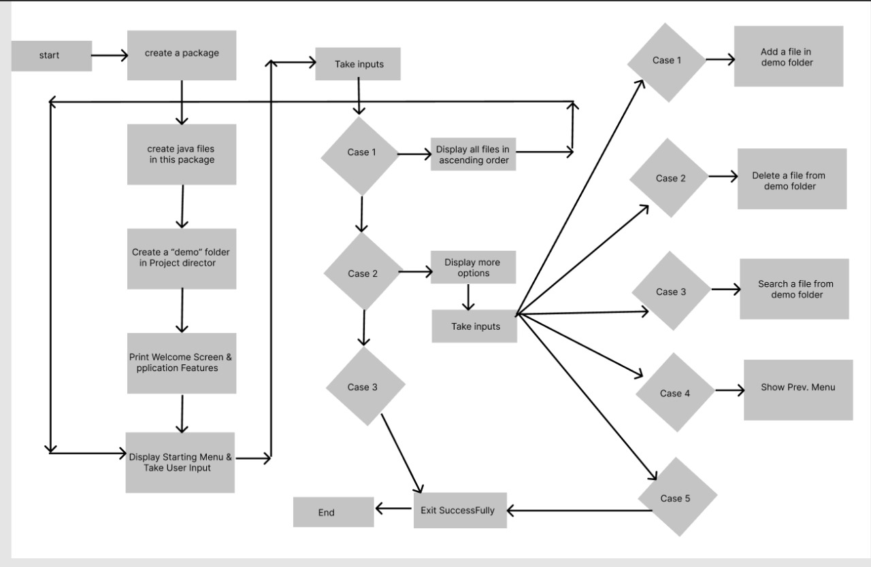

**Project Details: -**

Create a java project in Eclipse

Create a package com.java.lockedme

Create files names

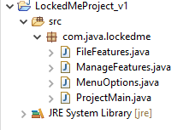

**Write a java code or create a main method in ProjectMain to run the application.**

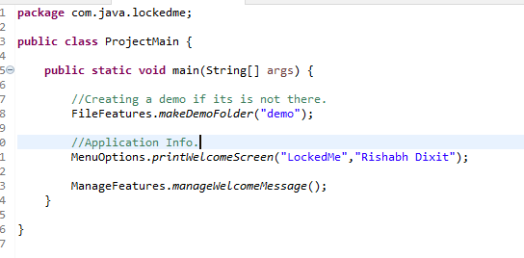

**Write a java code in MenuOption to give User to perform actions.**

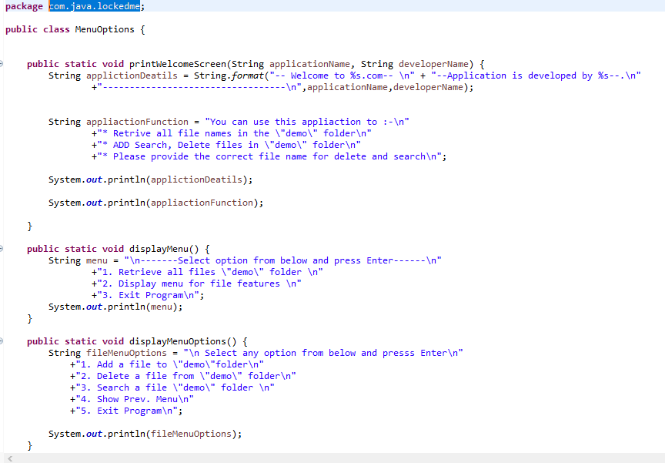

**Write a java code in ManageFeatures to handle all the option in this application.**

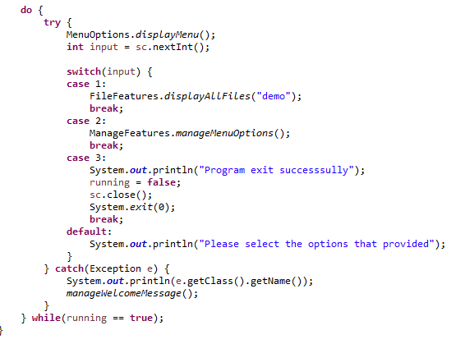

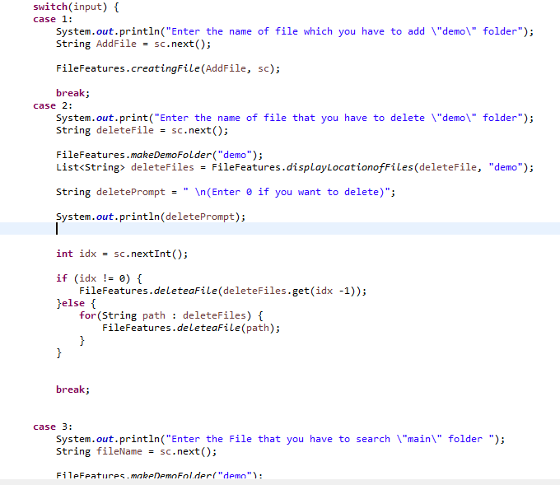

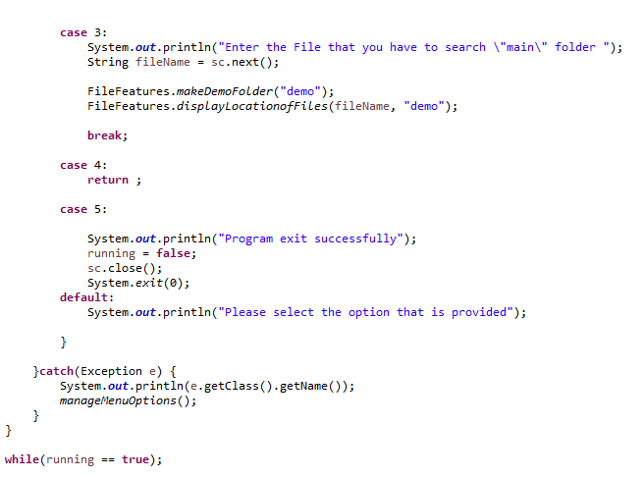

**Write a java code in FileFeatures to perform all operation in the application.**

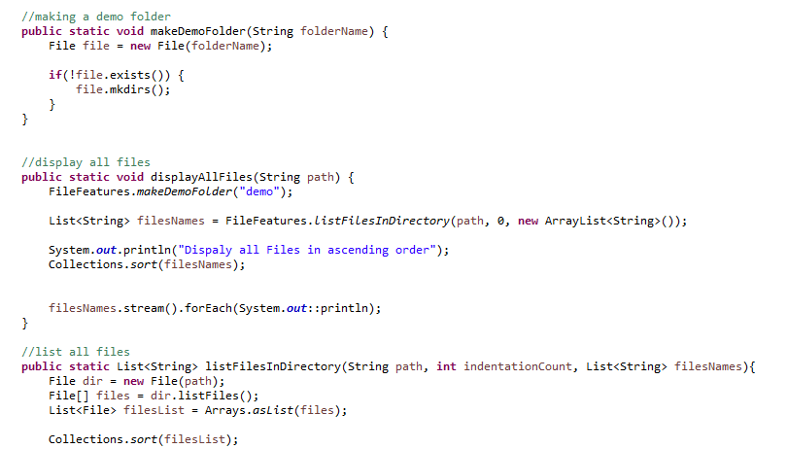

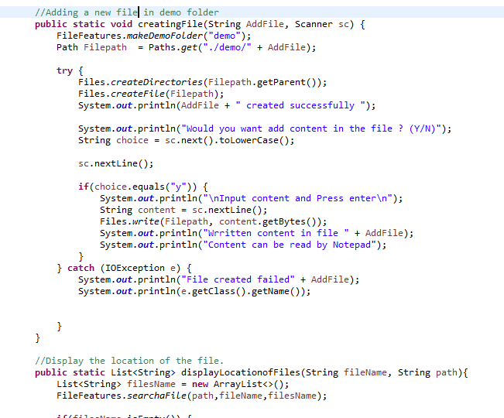

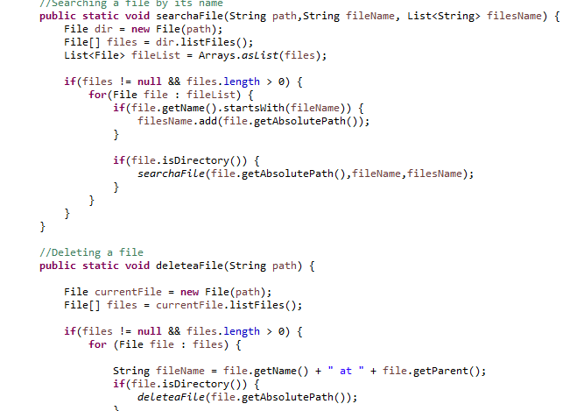

**GitHub Repo link -:** <https://github.com/dixitrishabh/LockedMe-Projectv1>

**Your conclusion on enhancing the application and defining the USPs (Unique Selling Points):**

Allowing user to add a file in demo folder.

Allowing user to user to delete and search a given file from its name.

Allowing user to retrieve all file from demo folder.

The files will be sort in ascending order.

**Some USPs –**

The application works very smoothly while taking inputs from the user.

The user can add, delete and search a file.

The user moves back in the main menu.

All files will be sort in Ascending order.

The application handle mismatch input exceptions.